Performance Testing

20 concurrent users- View 5 items per visit

Blaze meter Report

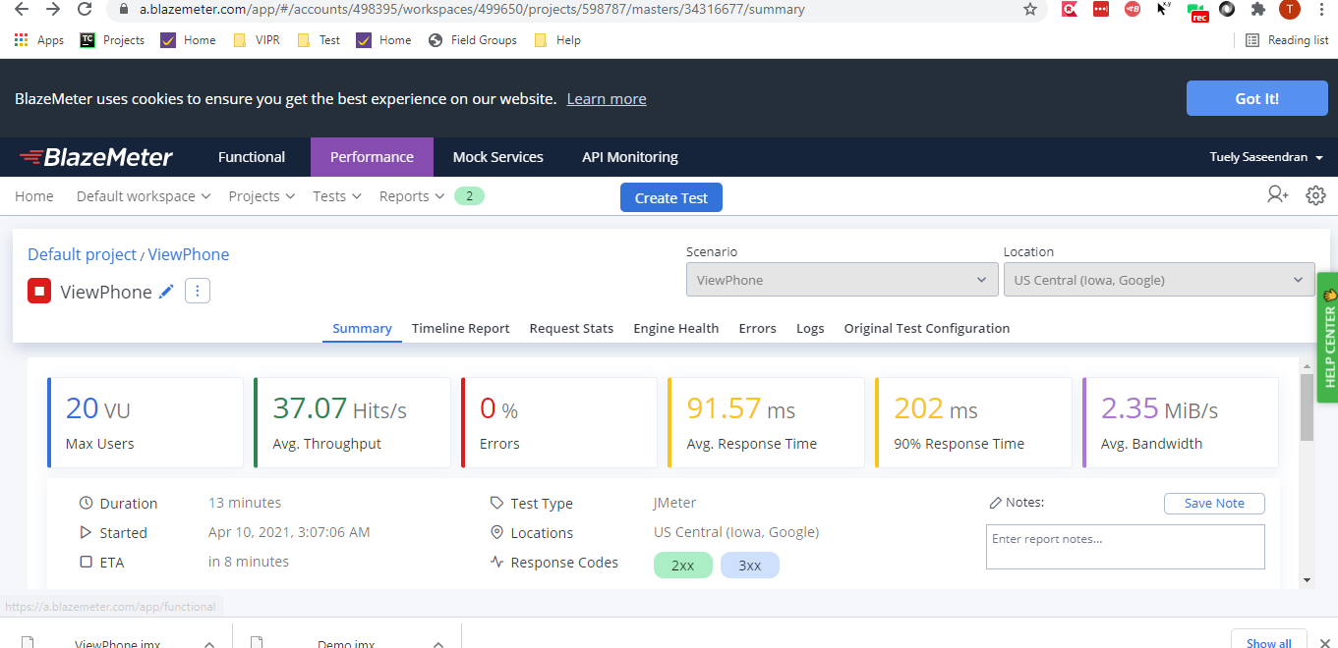

Jmeter Result

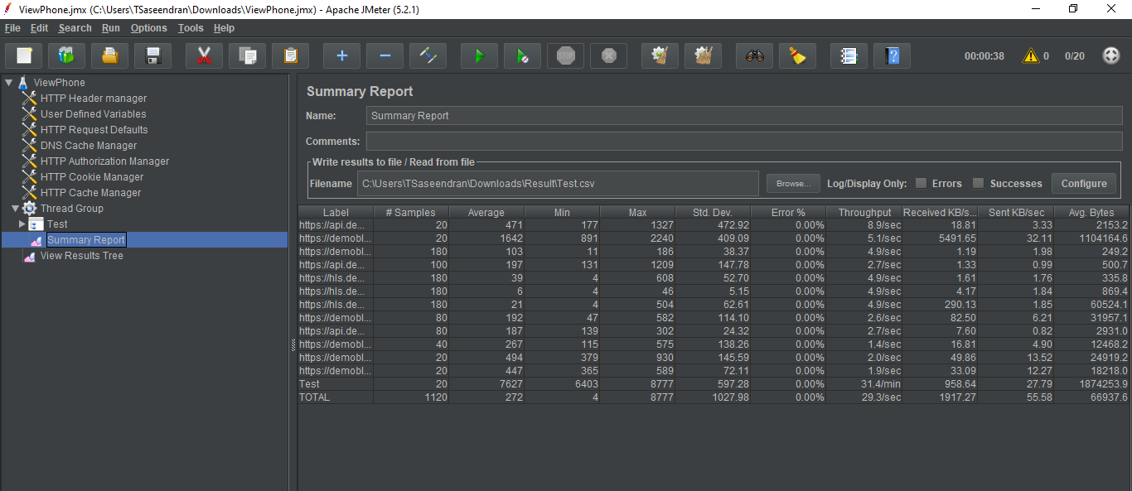

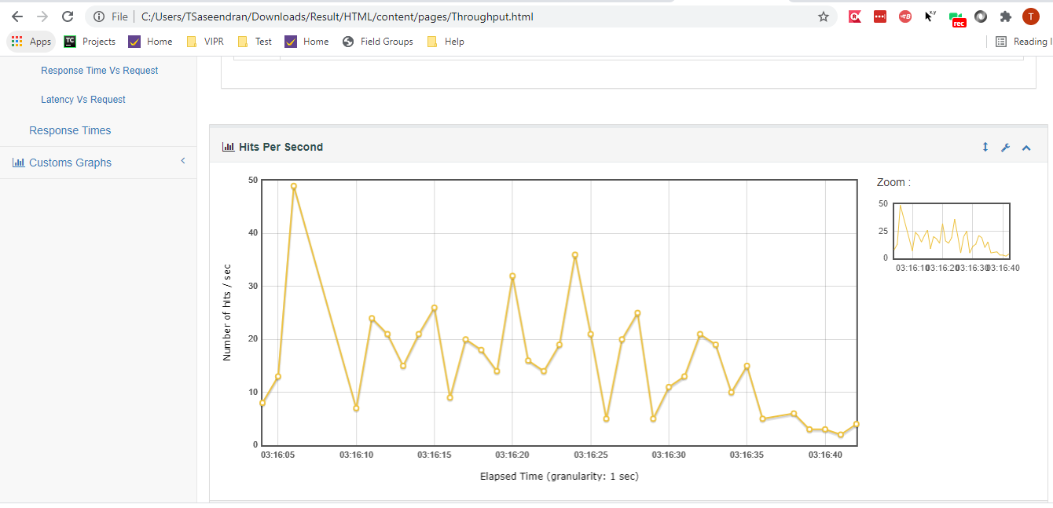

Test Script- https://a.blazemeter.com/app/#/accounts/498395/workspaces/499650/projects/598787/masters/34316677/summary